SCHOOL OF COMPUTER SCIENCE AND ARTIFICIAL INTELLIGENCE |  |  |  |  | DEPARTMENT OF COMPUTER SCIENCE ENGINEERING
Program Name: B. Tech |  |  |  | Assignment Type: Lab |  |  | Academic Year:2025-2026
Course Coordinator Name |  |  |  | Venkataramana Veeramsetty
Instructor(s) Name
  Dr. V. Venkataramana (Co-ordinator)
  Dr. T. Sampath Kumar
  Dr. Pramoda Patro
  Dr. Brij Kishor Tiwari
  Dr.J.Ravichander
  Dr. Mohammand Ali Shaik
  Dr. Anirodh Kumar
  Mr. S.Naresh Kumar
  Dr. RAJESH VELPULA
  Mr. Kundhan Kumar
  Ms. Ch.Rajitha
  Mr. M Prakash
  Mr. B.Raju
  Intern 1 (Dharma teja)
  Intern 2 (Sai Prasad)
  Intern 3 (Sowmya)
  NS_2 ( Mounika)
Course Code |  |  | 24CS002PC215 | Course Title |  | AI Assisted Coding
Year/Sem |  |  | II/I | Regulation |  | R24
Date and Day  of Assignment |  |  | Week7 - Monday | Time(s)
Duration |  |  | 2 Hours | Applicable to  Batches
AssignmentNumber:14.1(Present assignment number)/24(Total number of assignments)
 | Q.No. | Question |  |  |  |  |  | Expected Time  to complete
 | 1 | Lab 14: Web Design Application – AI-Assisted HTML/CSS/JS Generation  Lab Objectives  - Design functional, visually appealing web applications using HTML, CSS, and JavaScript with AI assistance.  - Apply responsive, accessible, and interactive design principles.  - Create practical UI components for real-world web applications.  - Use AI to optimize layout, UX, and performance.  Task 1 – Portfolio Website Design  You are building a personal portfolio website to showcase your work.  Requirements:  - Create sections for About Me, Projects, and Contact.  - Use AI to:  - Suggest color palettes and typography.  - Create a responsive layout with Grid/Flexbox.  - Add smooth scrolling navigation.  Ouput:  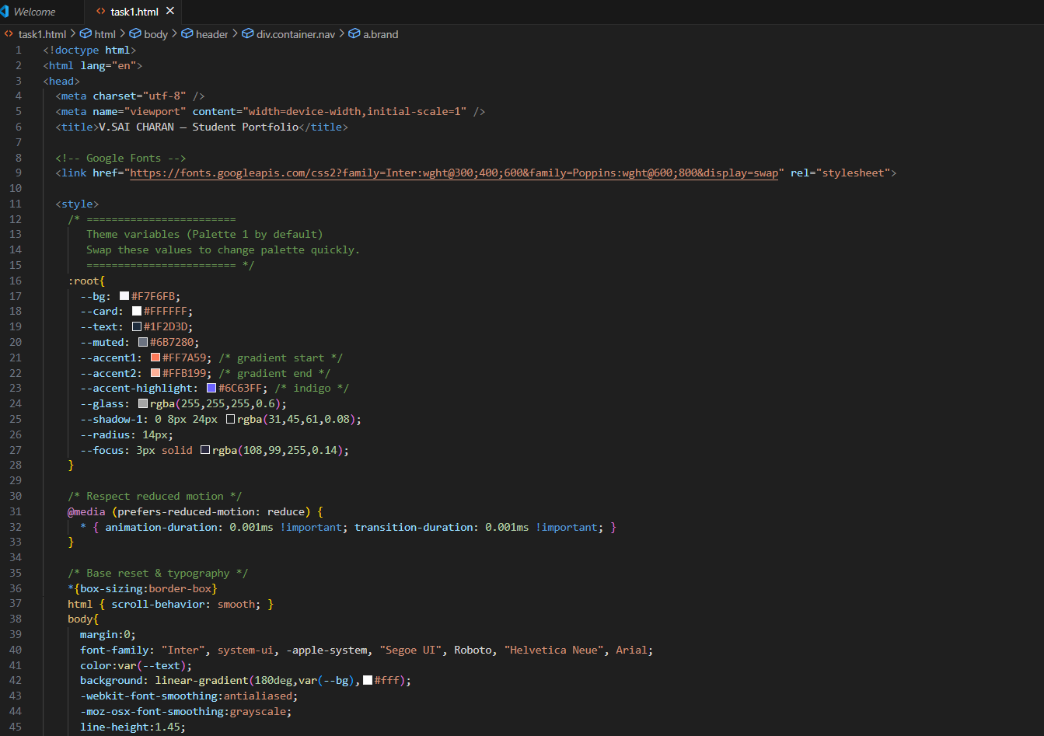  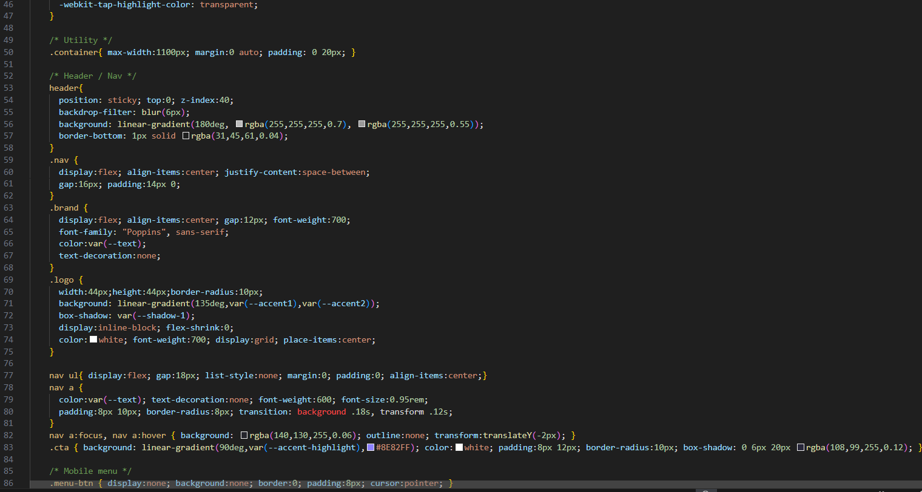  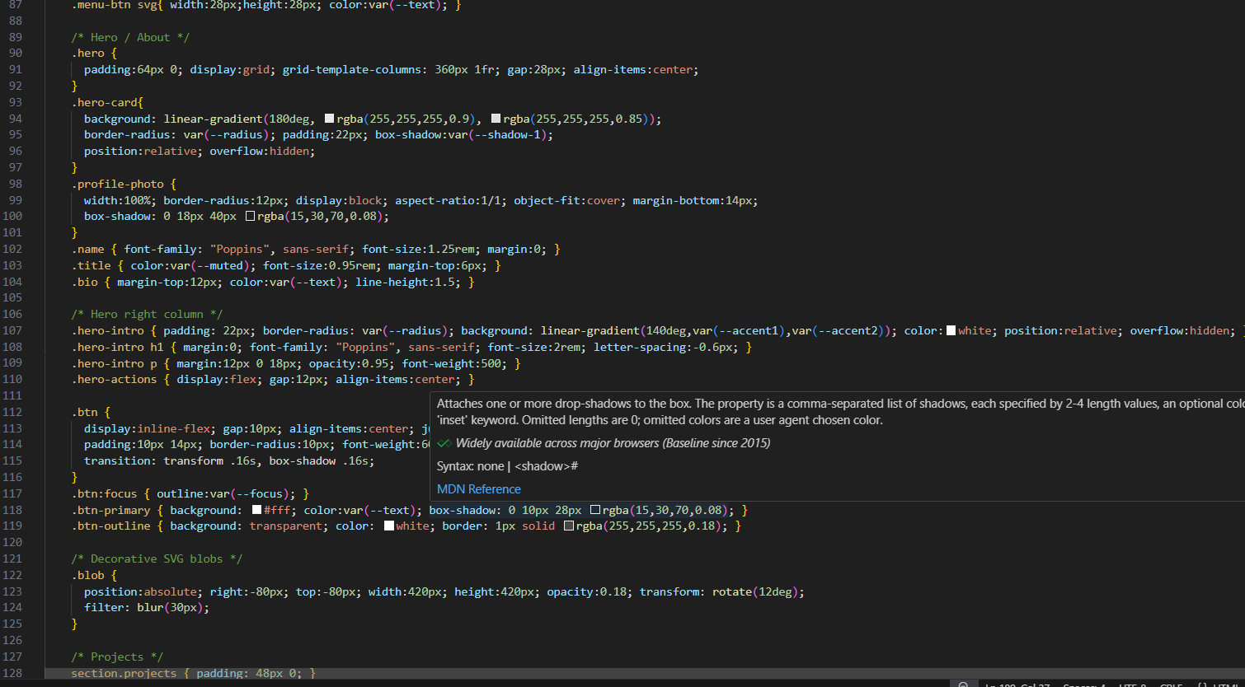  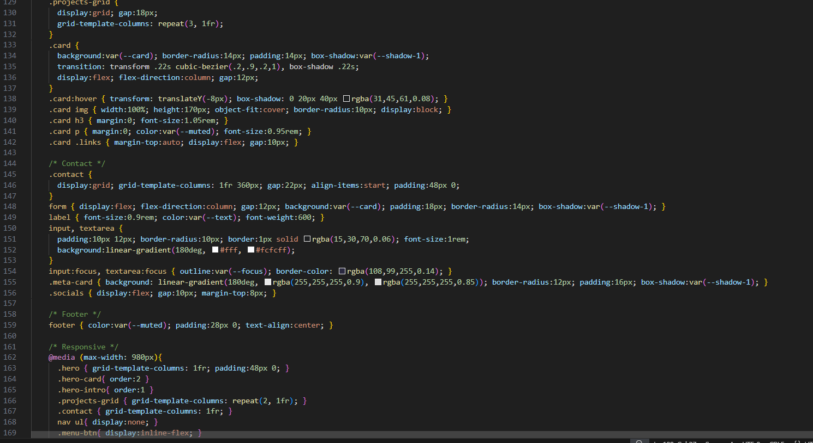  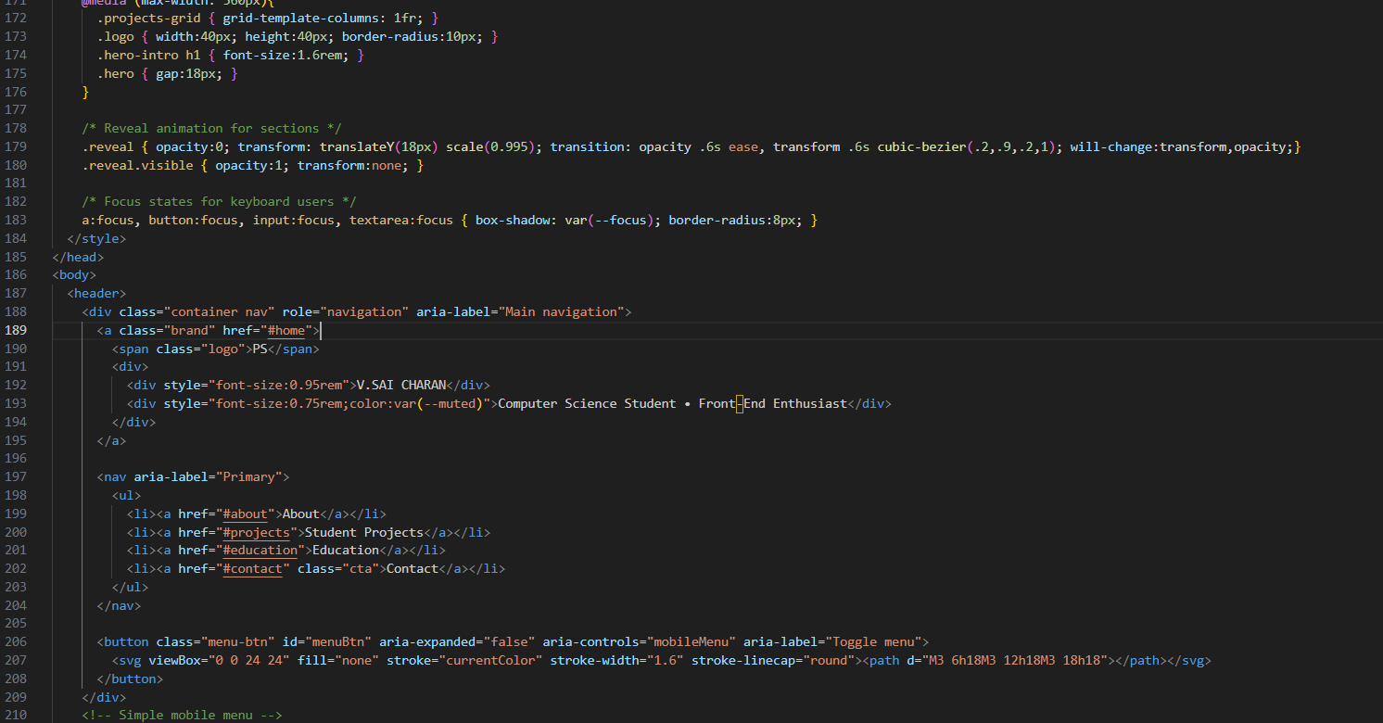  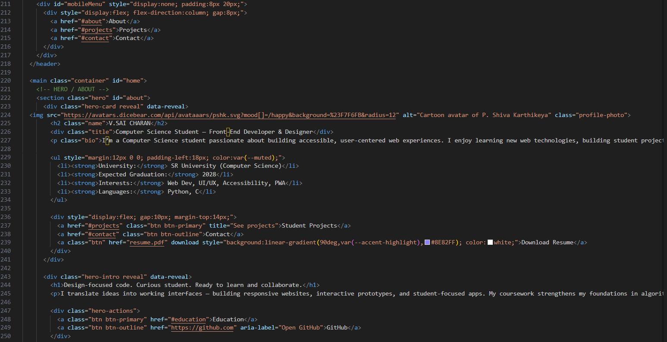  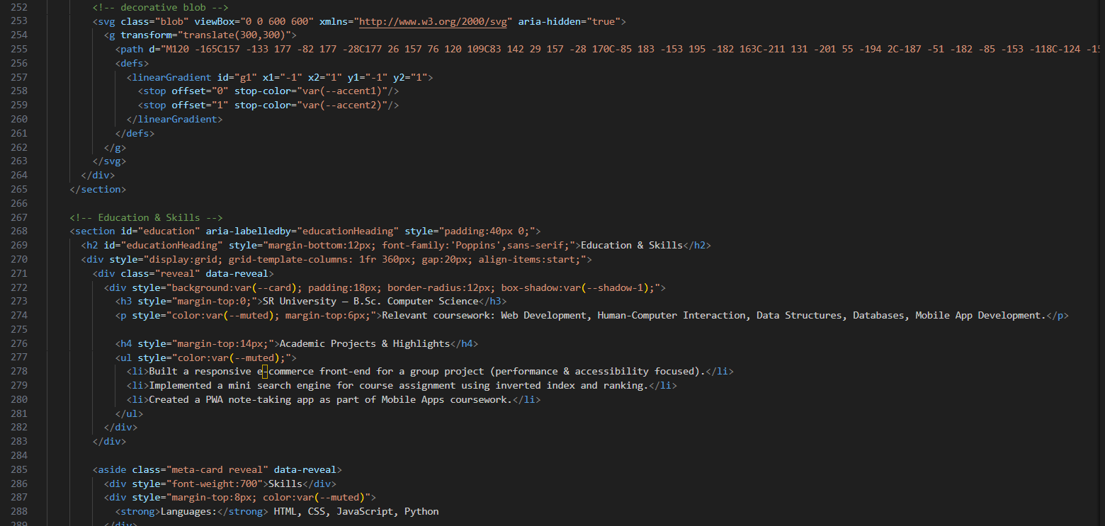  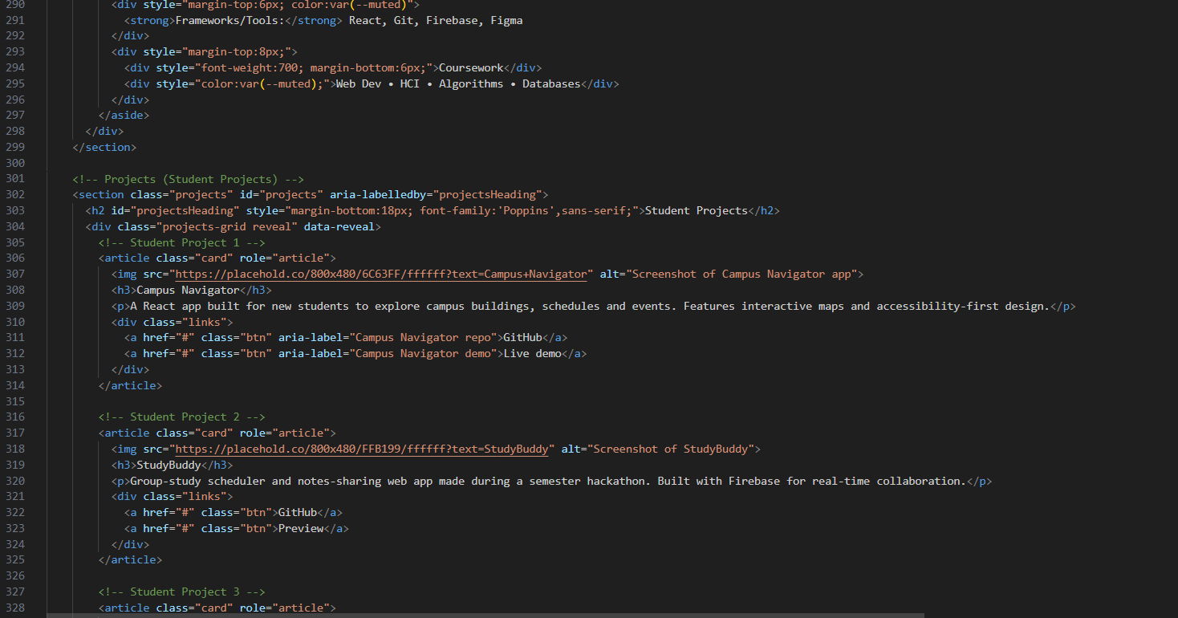  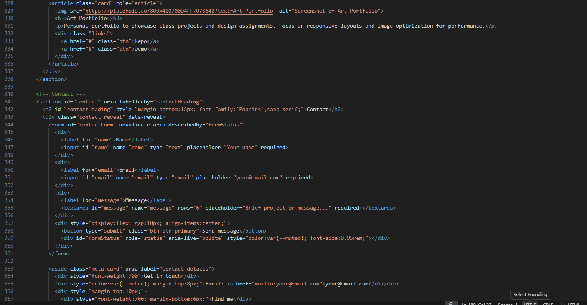  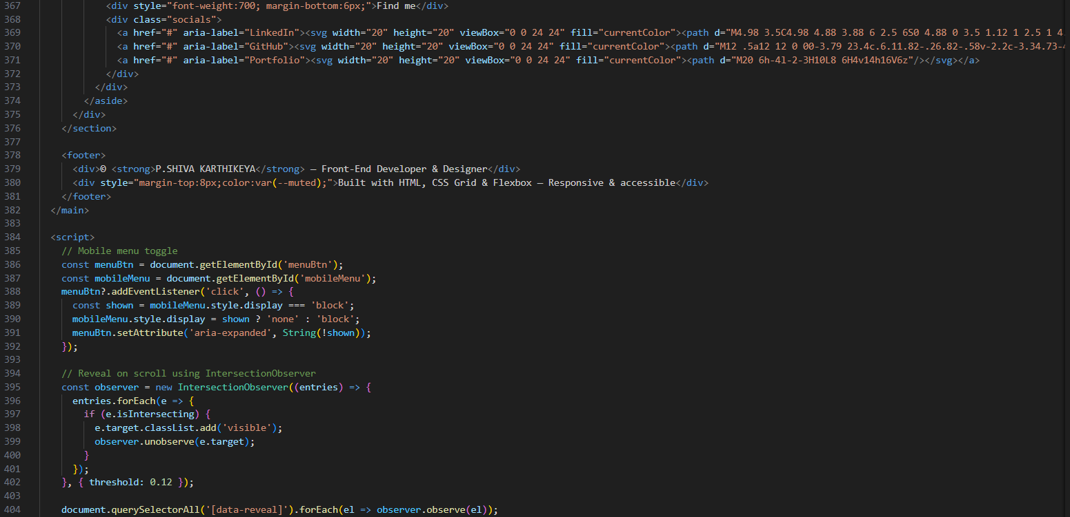  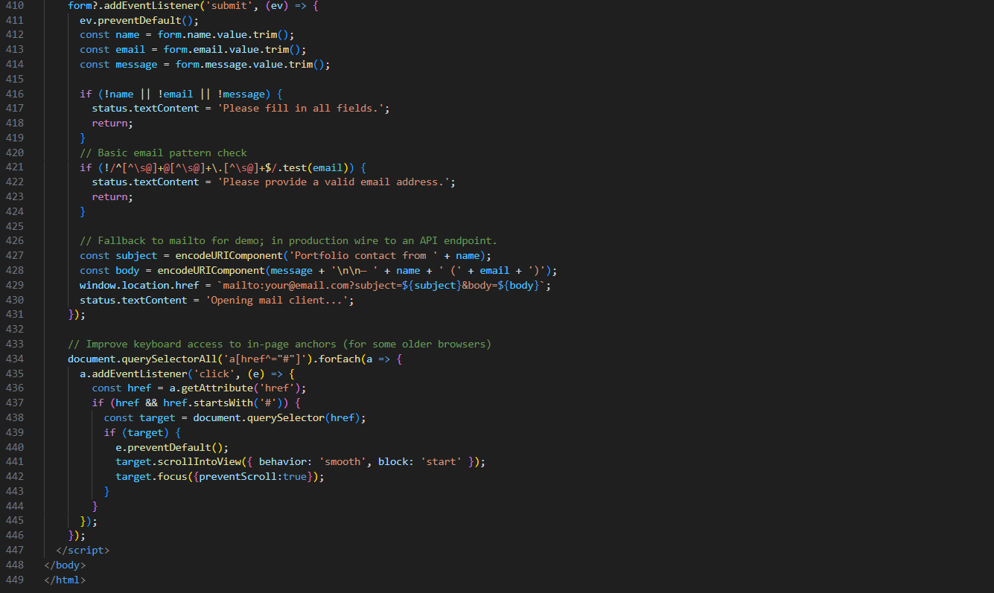  Task 2 – Online Store Product Page  Design a product display page for an online store.  Requirements:  - Display product image, title, price, and "Add to Cart" button.  - Use AI to:  - Style with BEM methodology.  - Make layout responsive.  - Add hover effects and "Add to Cart" alert.  Output:  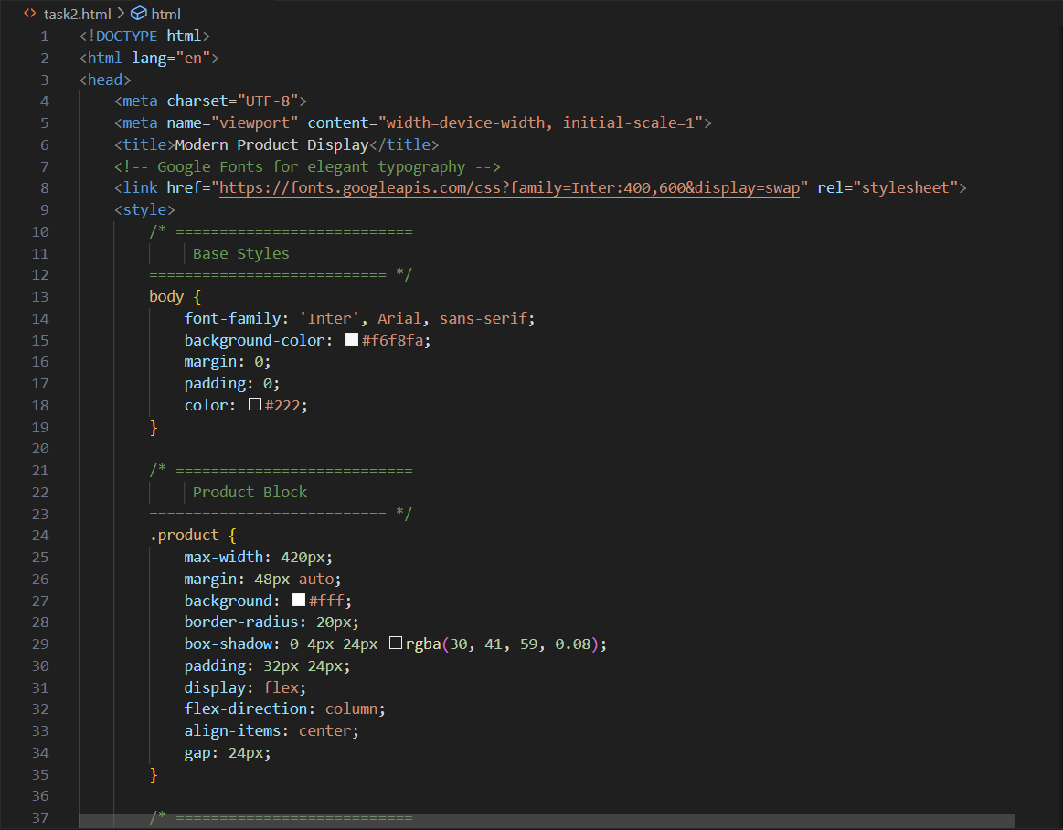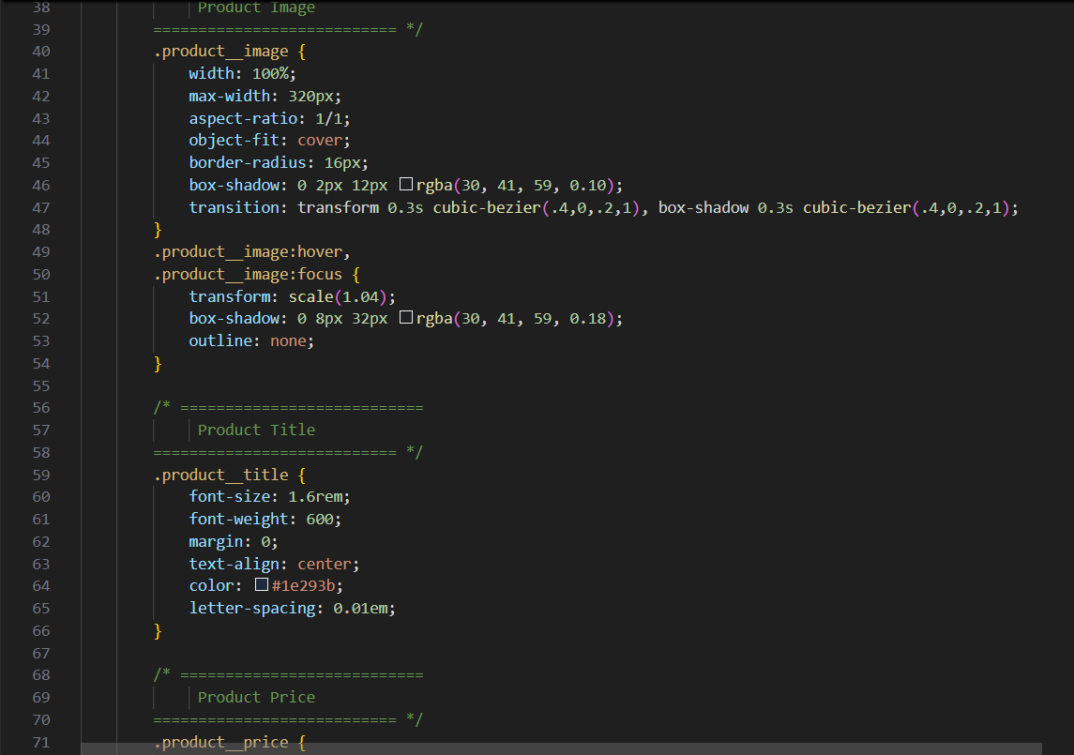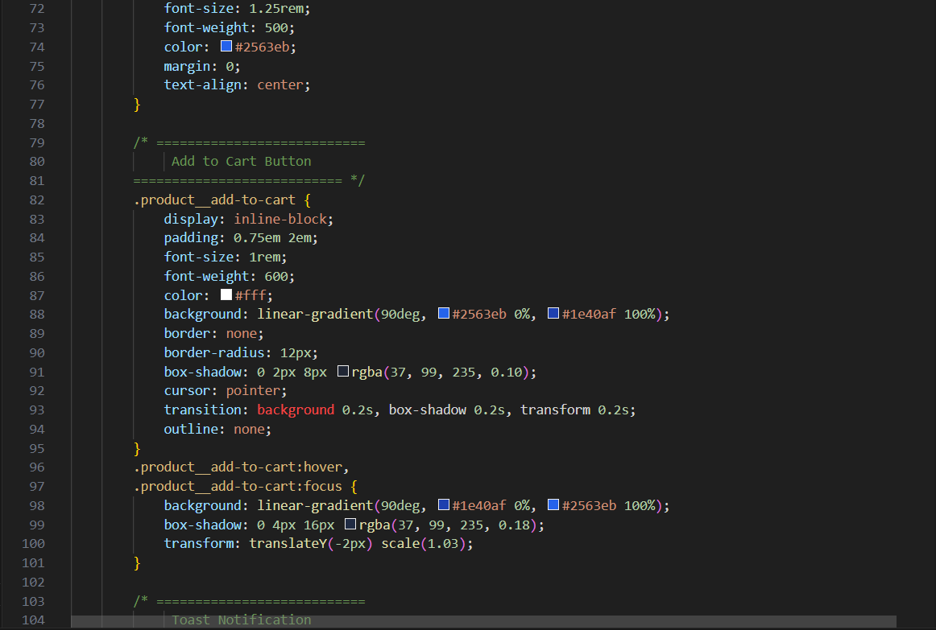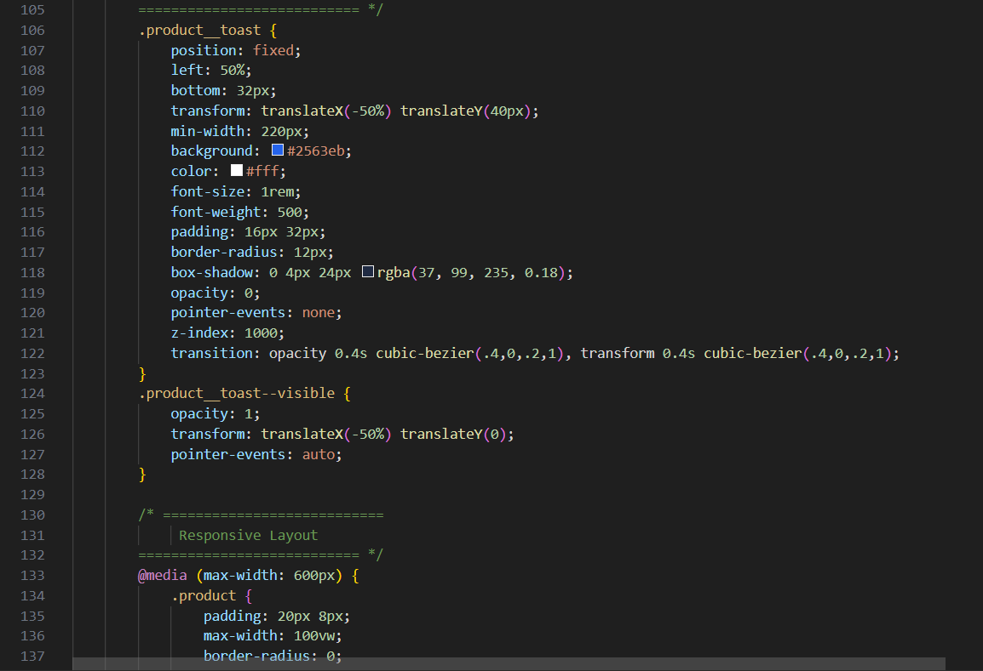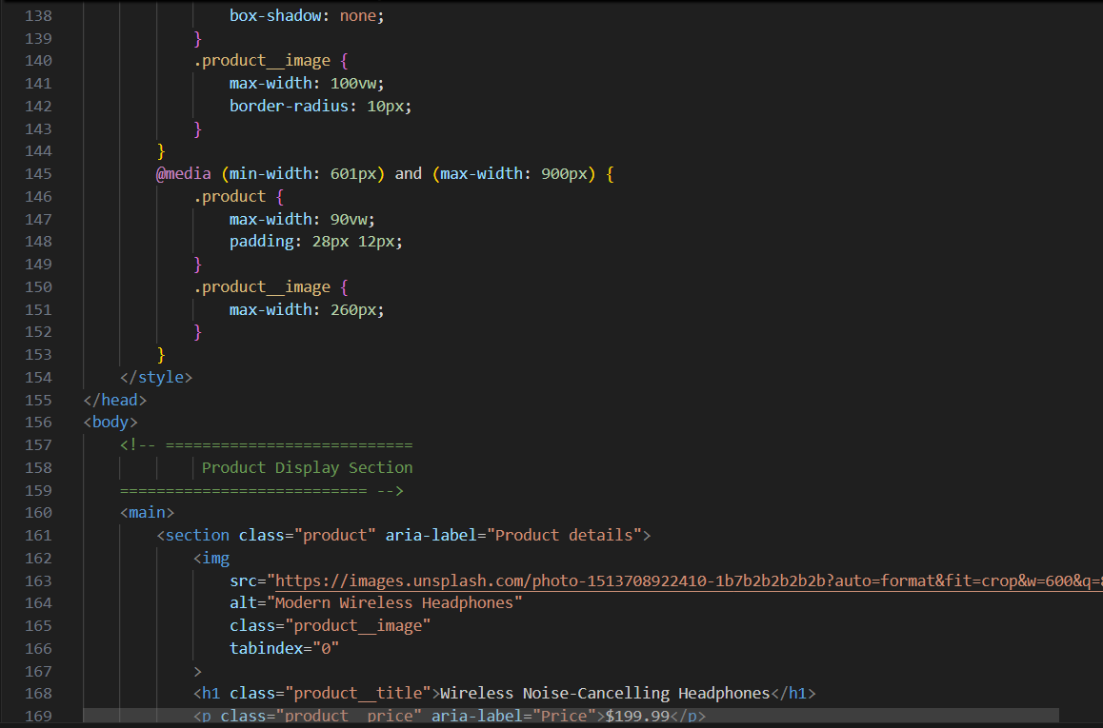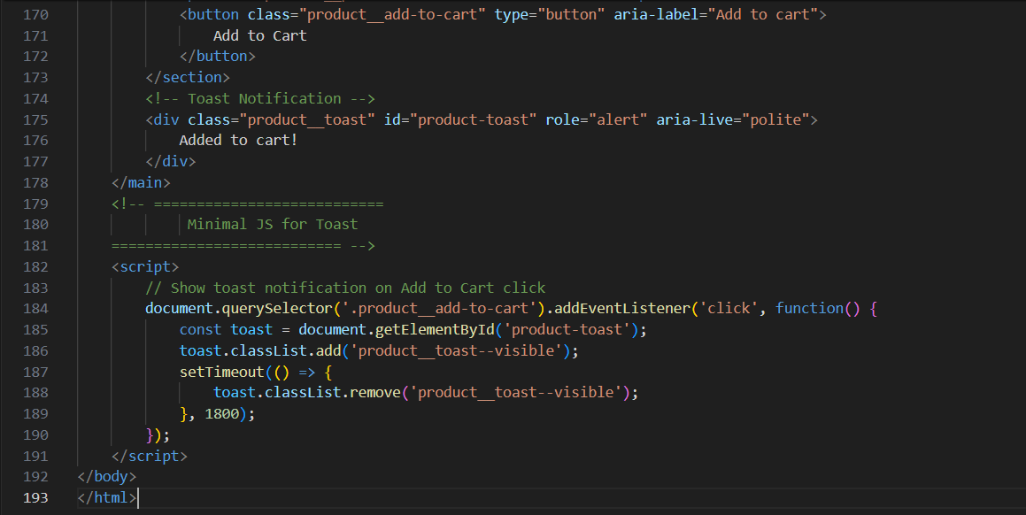  Task 3 – Event Registration Form  Build an event registration form for a conference.  Requirements:  - Collect name, email, phone number, and session selection.  - Use AI to:  - Add form validation with JavaScript.  - Make the form accessible with labels and ARIA.  - Style with a professional look.  Output:  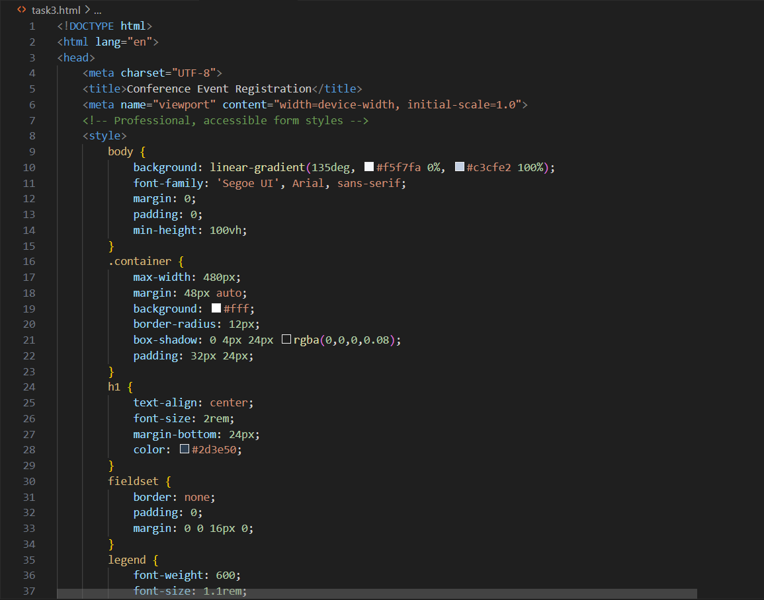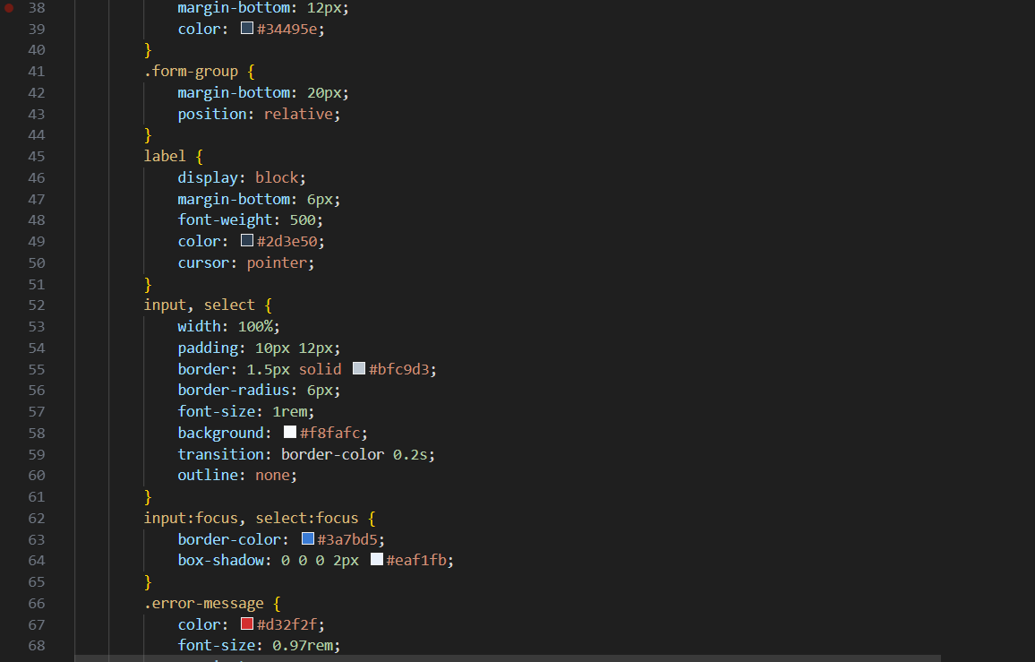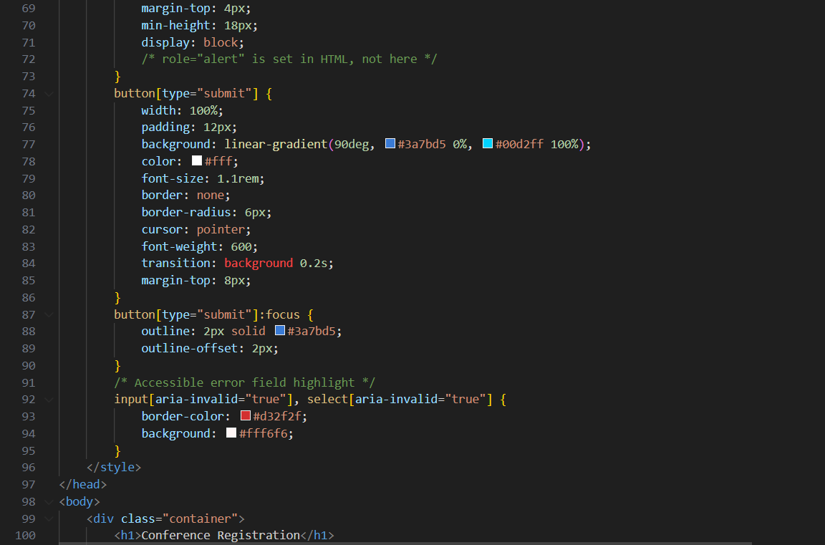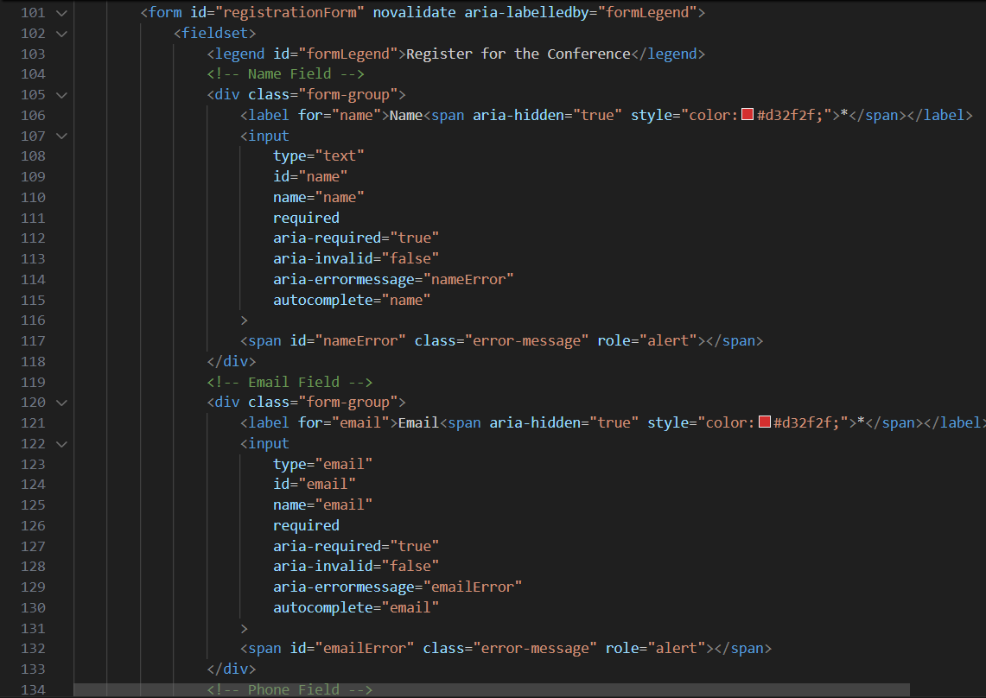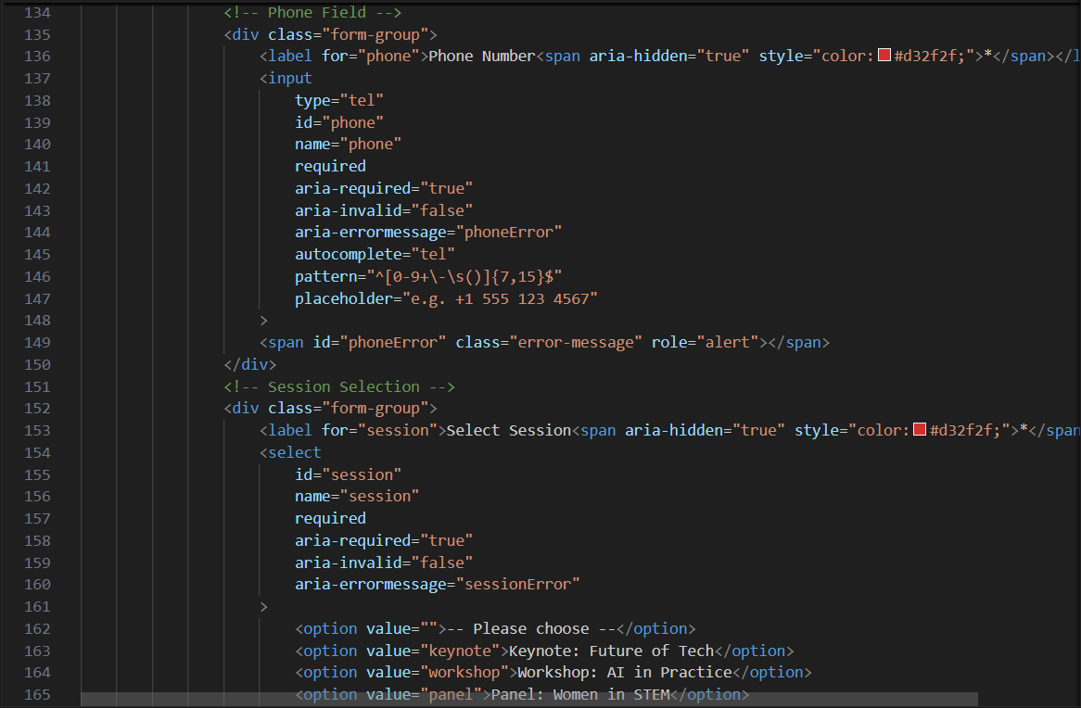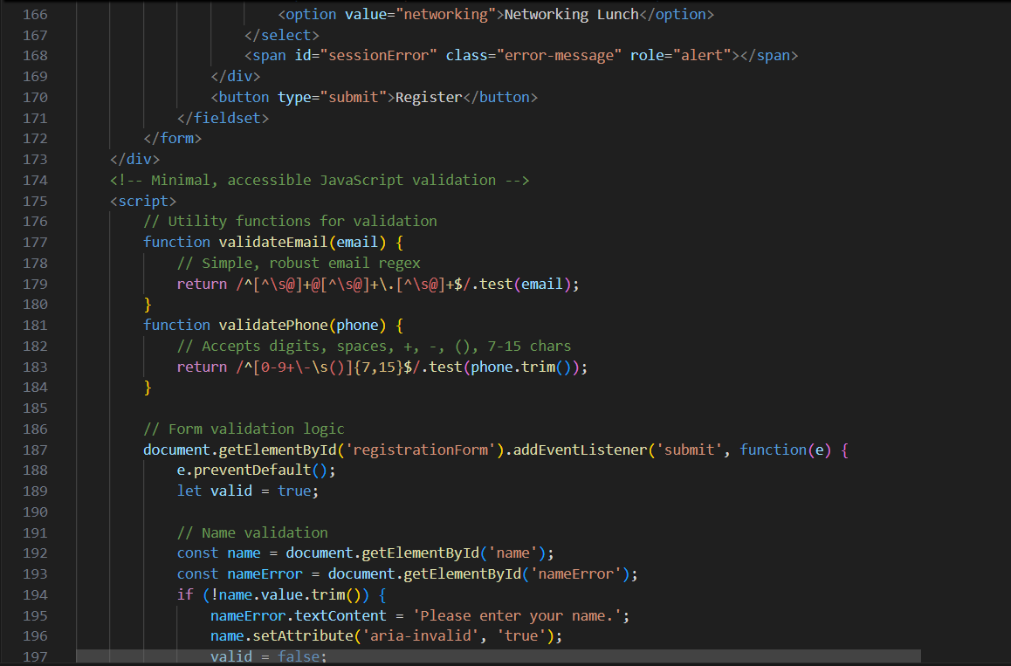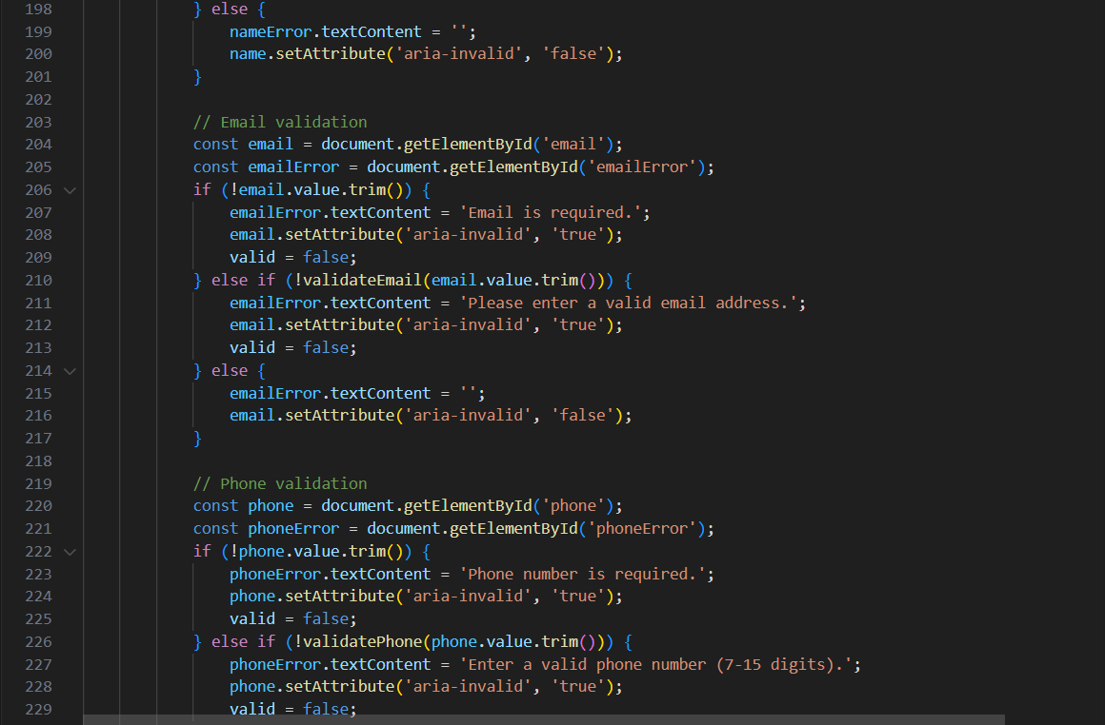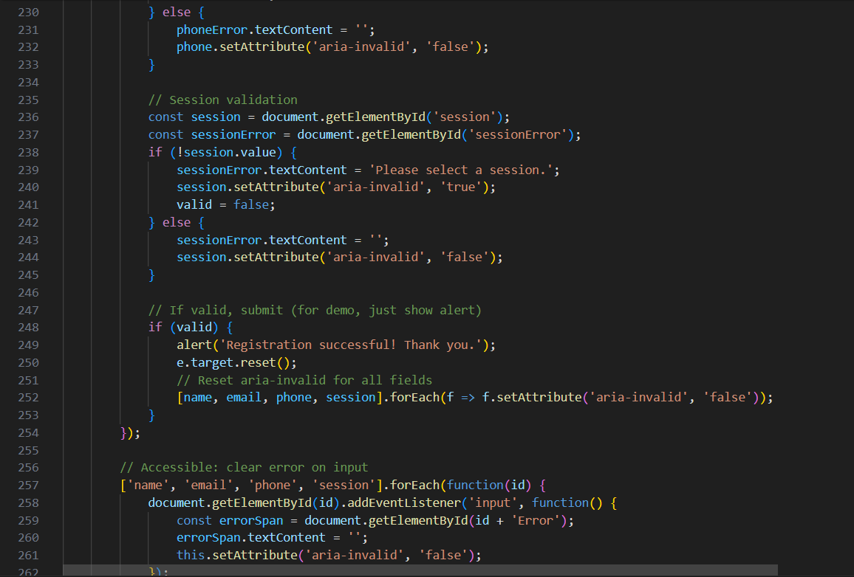  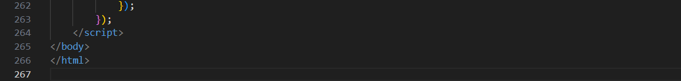  Task Description #4 (Data – Fetch API & Render List with Loading/Error States)  - Task: Fetch JSON from an API and render items to the DOM with loading and error UI.  - Instructions:  - Ask AI to write fetch() logic, create DOM nodes safely, and add skeleton/loading text.  Output:  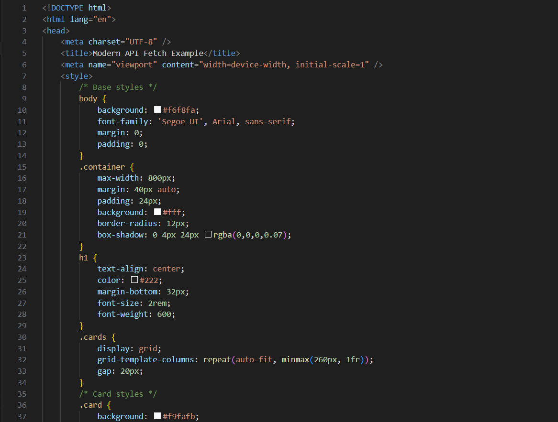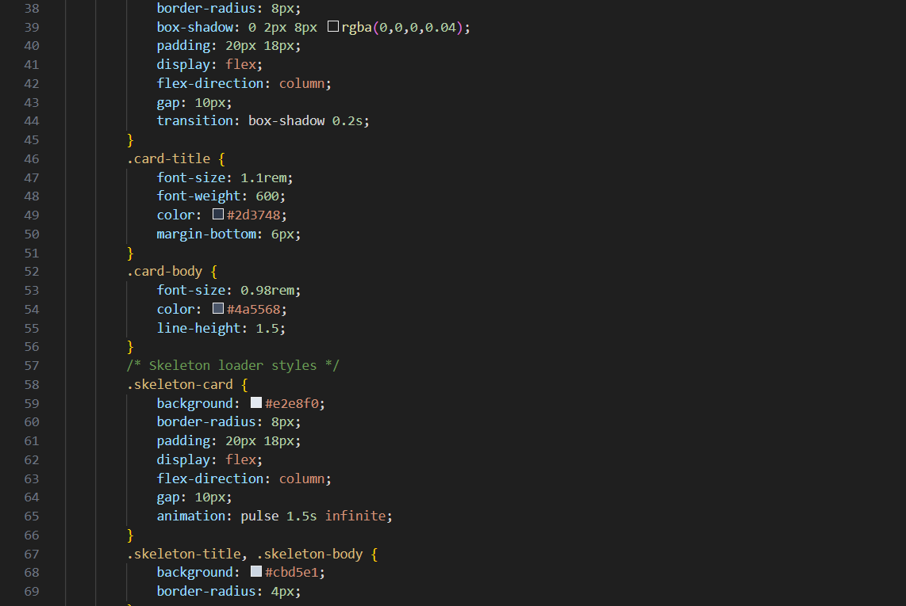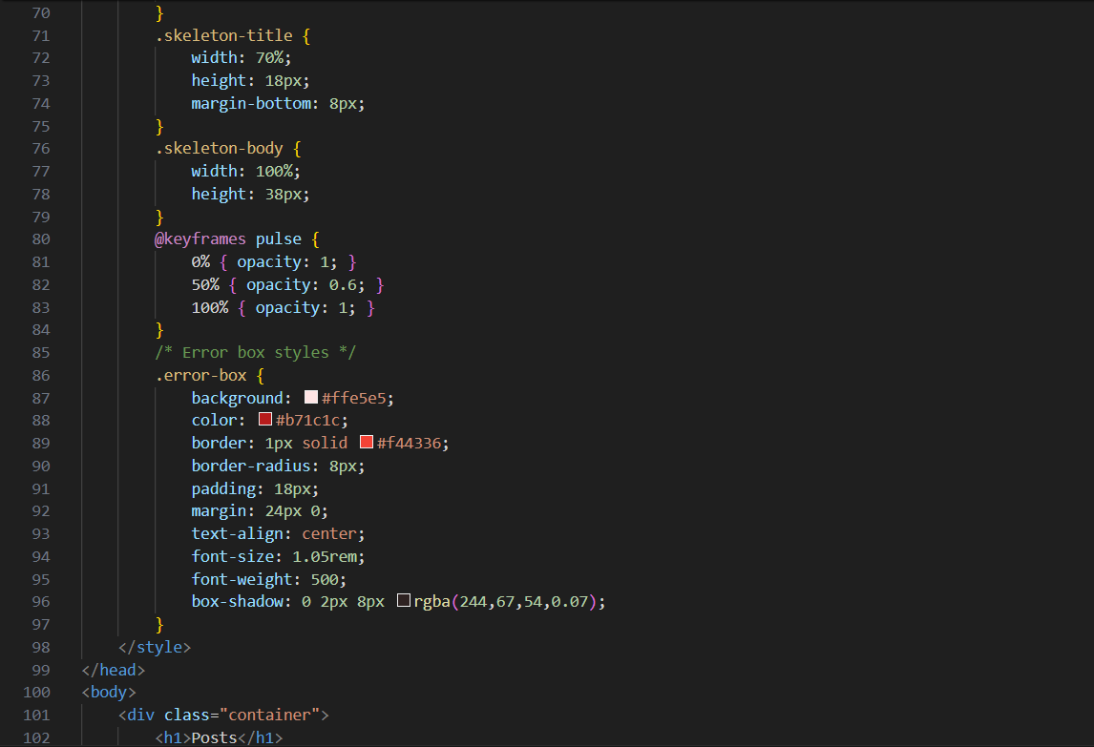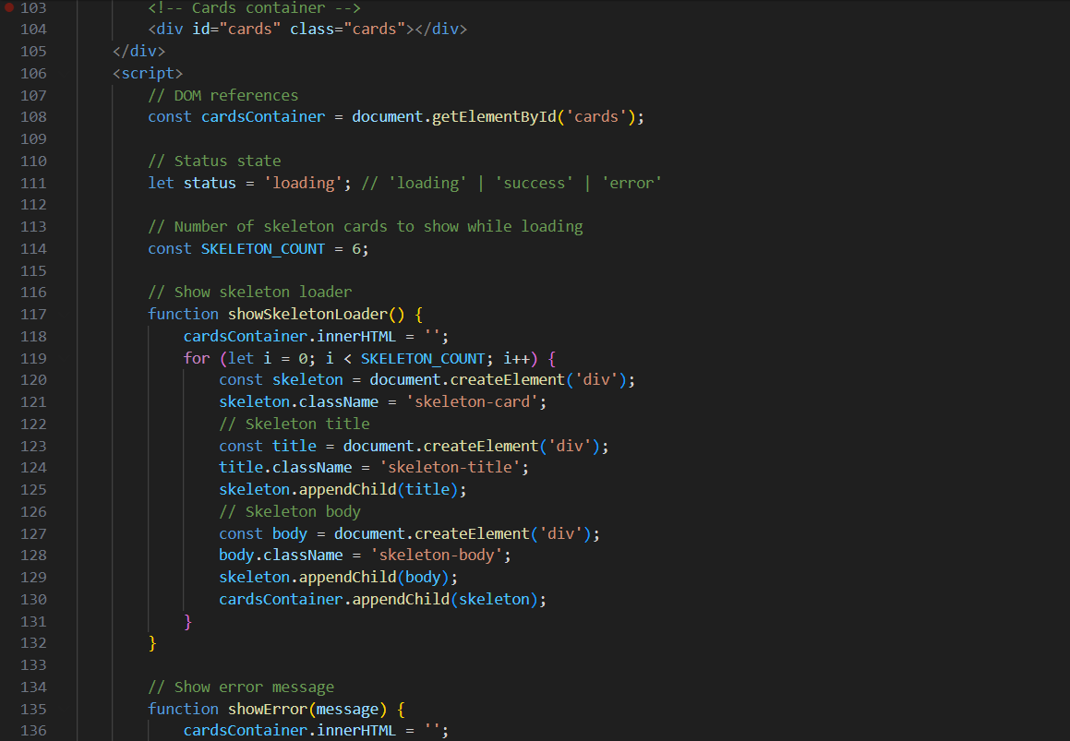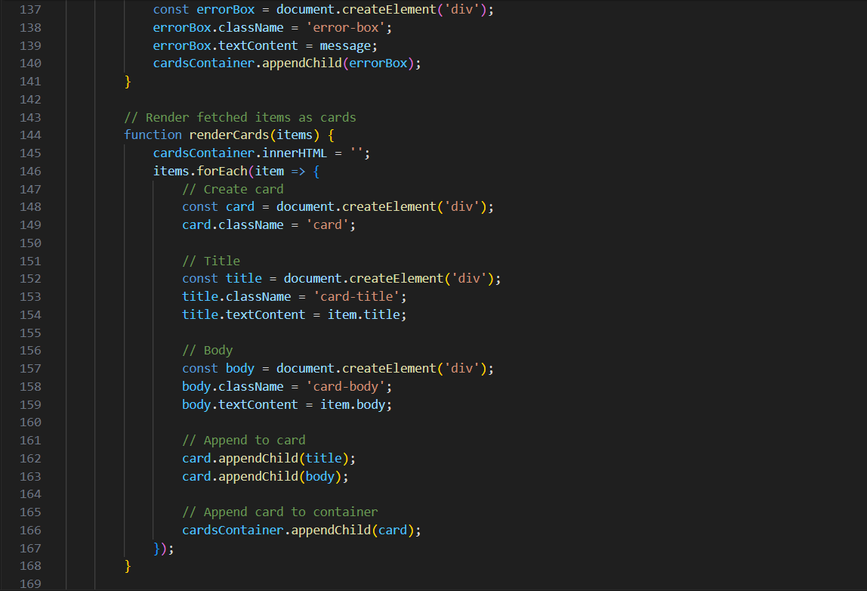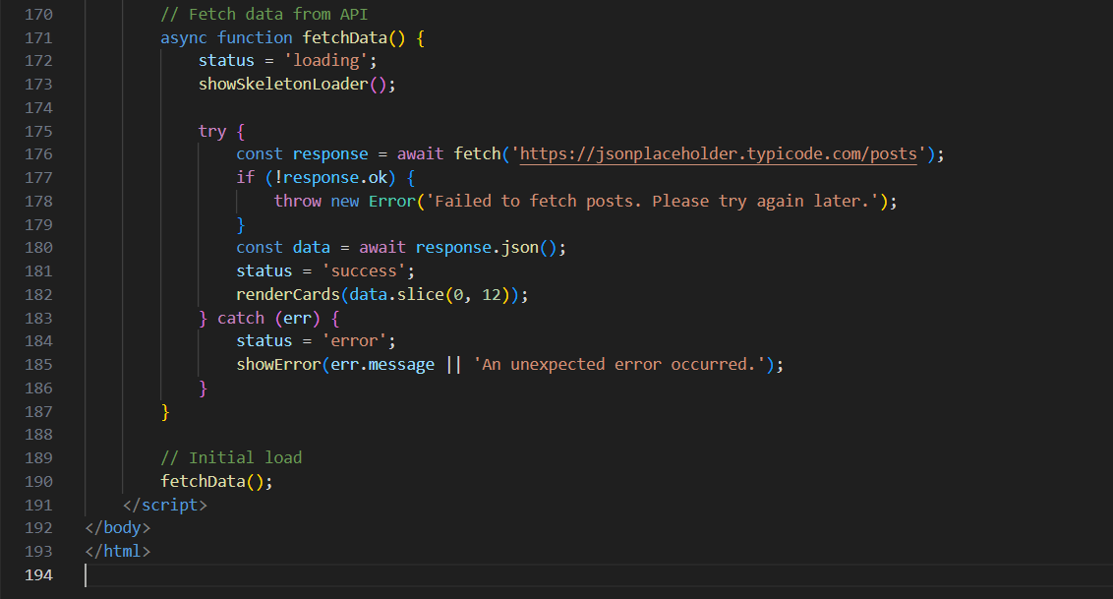  ✅ Deliverables (For All Tasks)  - AI-generated prompts for code and test case generation.  - At least 3 assert test cases for each task.  - AI-generated initial code and execution screenshots.  - Analysis of whether code passes all tests.  - Improved final version with inline comments and explanation.  - Compiled report (Word/PDF) with prompts, test cases, assertions, code, and output. |  |  |  |  |  | Week7 - Monday

